Creating the database
After reviewing the options for creating the database, we settled on supabase. First, we created an appropriate organisation and project on supabase, followed by creating our table:

In the table we put the fields we planned during the design of the database, following the types and restrictions we planned:
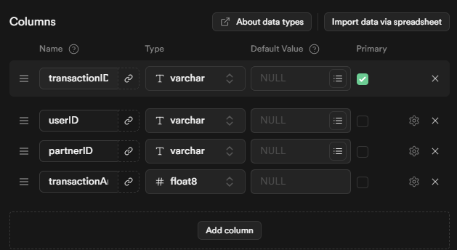
As the project MVP does not require a full authentication system, we made this table allow anonymous access, so that data can be written and wrote to it without using the supabase authentication system:
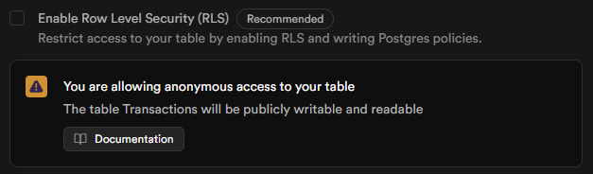
Finally, to meet MVP requirements, we populated the table with some very basic data, with the transactionID being a randomly generated UID:
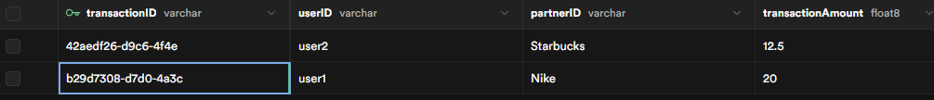

Creating the Cronjob
We have previously created cronjobs in our first year of programming at Nottingham, we will again be using cron-job.org for our cronjob:
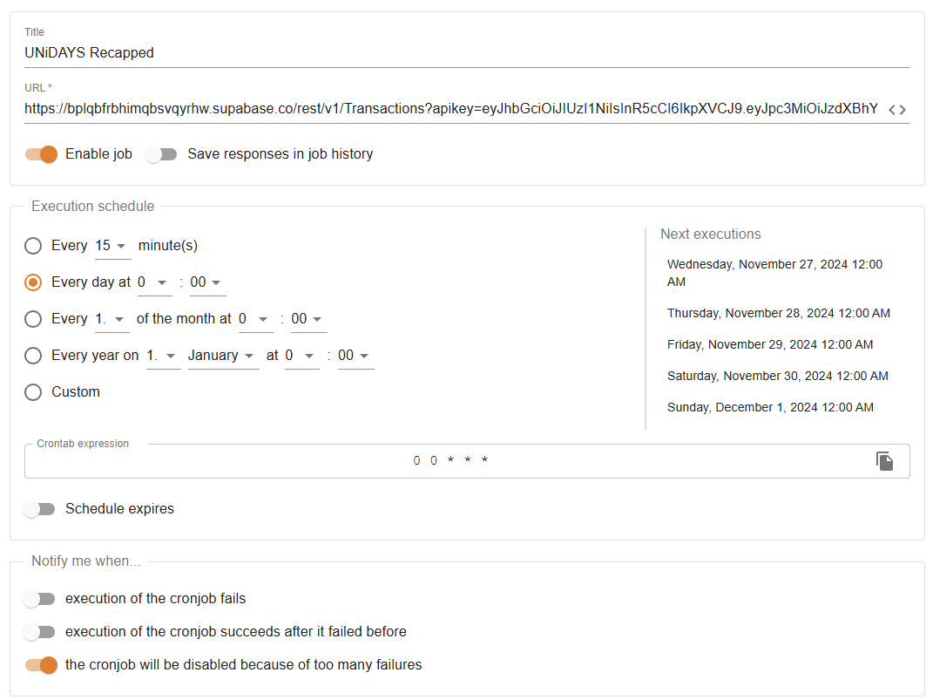
We set the cronjob to ping once a day since this is enough to meet supabase criteria to keep the database up and running. We then ran a test run to make sure it works:
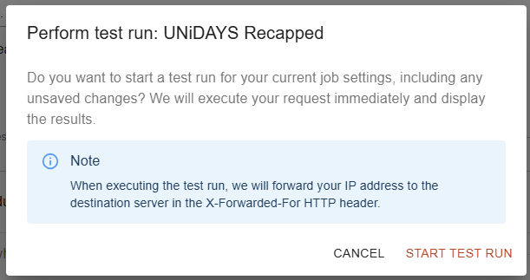
This was a success:
